**Microprocessor Lab Report (Assignment - 2)**

Bisakh Mondal 001810501079

Format: Question | Assembly Code (Memory Address, OpCode, Mnemonics, Comments)

(* The programs run in simulator seamlessly, though while running into 8085 it's better to use **RST5** instead of **HLT** to return the control to monitor program, without stopping the processor by **HLT**)

**(* Simulator: GNUSim8085, ( here Only the numbers which can be stored in memory is decimal (not hex format(maybe for better/easy user's interaction)**

**So for BCD operations** [**this**](https://www.sim8085.com/) **online simulator has been used)**

**(Q1)** 2 Numbers EAH and BDH are stored in 2050H and 2051H respectively, write a program to assemble them as ABH and store them in 2052H

|  |
| --- |
| 2200 3A 50 20 LDA 2050H; Load Content of EA into Accumulator 2203 E6 0F ANI 00FH;AND operation with 4 set bits LSB ( 0FH = 15( Decimal)= 00001111(Binary)) to extract A   2205 4F MOV C,A; Move the accumulator content to a temporary C register. 2206 3A 51 20 LDA 2051H; Now Load the Content of BD into the accumulator.   2209 E6 F0 ANI 0F0H; AND Immediate with Accumulator with value 4 bits set MSB to extract B 220B 81 ADD C; Add B0H with 0AH   220C 32 52 20 STA 2052H; Store the result into 2052H 220F 76 HLT; |

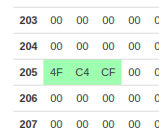 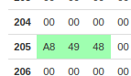

**(Q2)** Two numbers A and B are stored in 2050H and 2051H respectively write a program to perform AxB and store the result in 2052H and 2053H

|  |
| --- |
| 2200 2A 50 20 LHLD 2050H; Load HL pair with direct addressing from memory 2050H (the 2 numbers)   2203 3E 00 MVI A, 00H; initiating accumulator with 0 to store the mul 2205 55 MOV D, L; for Subsequent adding (as No Multiplication is supported in 8085) 2206 0E 00 MVI C,00H; Initiating the Carry count   2208 82 LOOP1: ADD D; Add D with Accumulator 2209 D2 0D 022 JNC NOCARRY; Check if carry is generated. 220C 0C INR C; Increase Carry count 220D 25 NOCARRY: DCR H; H contains BH ( number of times) A should be added. 220E C2 08 022 JNZ LOOP1;   2211 6F MOV L,A; Move Accumulator to L register 2212 61 MOV H,C; Move Carry to H register   2213 22 52 20 SHLD 2052H; Store to content by HL pair pointed to 2052H 2216 76 HLT; |

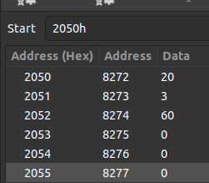 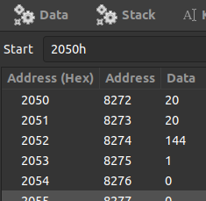

**(Q3)** Repeat 2 for BCD Numbers.

|  |
| --- |
| 2200 2A 50 20 LHLD 2050H; Load HL pair with direct addressing from memory 2050H (the 2 numbers)   2203 3E 00 MVI A, 00H; initiating accumulator with 0 to store the mul 2205 55 MOV D, L; for Subsequent adding (as No Multiplication is supported in 8085) 2206 0E 00 MVI C,00; Initiating the Carry count   2208 82 LOOP1: ADD D; Add D with Accumulator 2209 27 DAA; Decimal adjust after addition for BCD conversion 220A D2 0E 022 JNC NOCARRY; Check if carry is generated. 220D 0C INR C; Increase Carry count 220E 25 NOCARRY: DCR H; H contains BH ( number of times) A should be added.   220F C2 08 022 JNZ LOOP1;   2212 6F MOV L,A; Move Accumulator to L register 2213 4F MOV A, C; Move Carry to Accumulator.   ;2214 27 DAA; Perform Decimal adjust of the carry too.(for large mul) 2214 67 MOV H,A; Move Carry to H register   2215 22 52 20 SHLD 2052H; Store by HL pair pointed to 2052H   2218 76 HLT; |

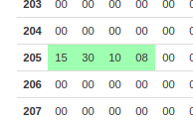 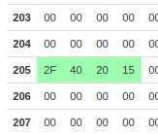

**(Q4)** N numbers are stored in consecutive m/m location starting from 2050H the value of N is stored in 204FH

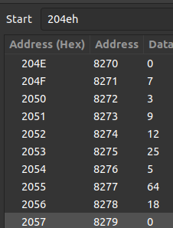

(i) Find Max of N numbers.

|  |
| --- |
| 2200 21 50 20 LXI H, 2050H; Store 2050H in HL register pair, the m/m location where consecutive numbers are stored. 2203 3A 4F 20 LDA 204FH; Load content of 204FH (Number of elements N) in accumulator    2206 47 MOV B, A; Move N into B register 2207 AF XRA A; Exclusive or A with A to clear the content of Accumulator.   2208 BE LOOP: CMP M; Compare Accumulator with the content pointer by HL register pair.  2209 D2 0D 022 JNC CARRYRESET; If carry is generated or CY is set then (M> A) 220C 7E MOV A,M; Replace Accumulator with current Max 220D 23 CARRYRESET: INX H; Increment the HL pair( Extended register pair) 220E 05 DCR B; Decrement the counter( the N) 220F C2 08 022 JNZ LOOP; if Zero flag is set N =0 exit loop   2212 32 4E 20 STA 204EH; Store Accumulator( The Max) into 204EH 2215 76 HLT |

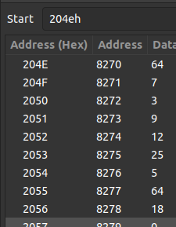

(ii) Find Min of N Numbers

|  |
| --- |
| 2200 21 50 20 LXI H, 2050H; Store 2050H in HL register pair, the m/m location where consecutive numbers are stored. 2203 3A 4F 20 LDA 204FH; Load content of 204FH (Number of elements N) in accumulator    2206 47 MOV B, A; Move N into B register 2207 7E MOV A,M; Move First element (with the content pointer by HL register pair.) to Accumulator for start comparing.   2208 BE LOOP: CMP M; Compare Accumulator with the content pointer by HL register pair.   2209 DA 0D 022 JC CARRYSET; If no carry is generated or CY is not set then (M< A) 220C 7E MOV A,M; Replace Accumulator with current Min 220D 23 CARRYSET: INX H; Increment the HL pair( Extended register pair)   220E 05 DCR B; Decrement the counter( the N) 220F C2 08 022 JNZ LOOP; if Zero flag is set ie. N =0 exit loop   2212 32 4E 20 STA 204EH; Store Accumulator( The Min) into 204EH 2215 76 HLT |

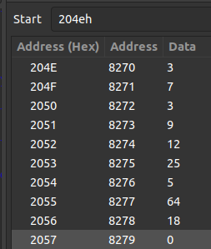

(iii) Sort Numbers in Ascending Order.

|  |
| --- |
| 2200 06 01 MVI B, 01H; 2202 21 4F 20 LOOP: LXI H, 204FH; Store 204FH in HL register pair, the m/m location where consecutive numbers are stored along with N. 2205 4E MOV C,M; Move the number of elements(N) to C register. 2206 23 INX H; Increment the HL pair( Extended register pair) 2207 0D DCR C; Decrease N by 1 to make it ready for counting. 2208 1E 00 MVI E, 00H; Register E is working somewhat like flag to check if the list got sorted or not   220A 7E LOOP2: MOV A, M; Move Content pointed to HL m/m location to accumulator. 220B 23 INX H; increment H 220C BE CMP M; Compare with next number ( consecutive 2 nums)   220D DA 17 22 JC AISNOTGREATER; if carry is generated A<M    ;else swapping the 2 consecutives. 2210 56 MOV D, M; 2211 77 MOV M,A; 2212 2B DCX H; 2213 72 MOV M,D; 2214 23 INX H; swapping Done. 2215 1E 01 MVI E, 01H; Set E flag that swapping occured.   2217 0D AISNOTGREATER: DCR C; Decrease loop count. 2218 C2 0A 022 JNZ LOOP2; if zero flag is not set continue looping.   221B 7B MOV A, E;  221C 0F RRC; Right rotate accumulator; 221D DA 02 022 JC LOOP; if E has 01H, RRC sets the CY flag, i.e need to traverse the list again.  2220 76 HLT; |

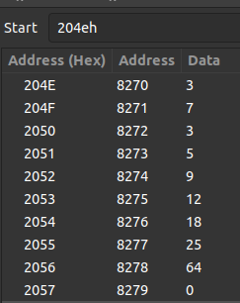

(iv) Sort Numbers in descending Order.

|  |
| --- |
| 2200 21 4F 20 LOOP: LXI H, 204FH; Store 204FH in HL register pair, the m/m location where consecutive numbers are stored along with N. 2203 4E MOV C,M; Move the number of elements(N) to C register. 2204 23 INX H; Increment the HL pair( Extended register pair) 2205 0D DCR C; Decrease N by 1 to make it ready for counting. 2206 1E 00 MVI E, 00H; Register E is working somewhat like flag to check if the list got sorted or not   2208 7E LOOP2: MOV A, M; Move Content pointed to HL m/m location to accumulator. 2209 23 INX H; increment H 220A BE CMP M; Compare with next number ( consecutive 2 nums)   220B D2 15 22 JNC AISGREATER; if carry is generated A>M    ;else swapping the 2 consecutives. 220E 56 MOV D, M; 220F 77 MOV M,A; 2210 2B DCX H; 2211 72 MOV M,D; 2212 23 INX H;   2213 1E 01 MVI E, 01H; Set E flag that swapping occured. 2215 0D AISGREATER: DCR C; Decrease loop count. 2216 C2 08 022 JNZ LOOP2; if zero flag is not set continue looping.   2219 7B MOV A, E; 221A 0F RRC; Right rotate accumulator; 221B DA 00 022 JC LOOP; if E has 01H, RRC sets the CY flag, i.e need to traverse the list again.  221E 76 HLT; |

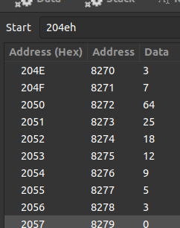

**(Q5)** N numbers are stored in consecutive m/m location starting from 2050H the value of N is Stored in 204FH write a program to copy the even odd numbers starting from 2100H and 2200H Store the total number of ODD and EVEN in 2301H and 2300H.

|  |
| --- |
| 2200 31 00 045 LXI SP, 4500H; Store Stack Pointer with 4500H   2203 21 50 20 LXI H, 2050H; Store 2500H in HL pair the m/m where numbers are stored. 2206 01 00 021 LXI B, 2100H; For even numbers storing purpose 2209 11 00 022 LXI D, 2200H; For odd numbers storing purpose   220C 3A 4F 20 LDA 204FH; Load Accumulator with N(number of element) 220F F5 PUSH PSW; Push Acc and Flags to SP, since I already exhausted all registers.   2210 7E LOOP: MOV A, M; Move content of HL Pair to Accumulator.   2211 E6 01 ANI 001H; To check the LSB if zero flag is set it's even else odd. 2213 7E MOV A,M; Move original content to Acc   2214 C2 1C 22 JNZ NOTEVEN;     ; If even store it into location pointed by BC pair 2217 02 STAX B; 2218 03 INX B; Increment BC pair 2219 C3 1E 22 JMP REGULAR; No need to execute the odd part, jump regular execution    ; If odd store it into location pointed by DE pair 221C 12 NOTEVEN: STAX D; 221D 13 INX D;    ;pop Process status word or Accumulator + Flags into the same 221E F1 REGULAR: POP PSW; 221F 23 INX H; Increment HL pair 2220 3D DCR A; Decrease Accumulator   2221 F5 PUSH PSW; Repush with updates 2222 C2 10 22 JNZ LOOP; If N is not 0 keep looping.   2225 79 MOV A,C; 2226 32 00 023 STA 2300H; Store C, which denotes the number of Even writes.  2229 7B MOV A, E; 222A 32 01 023 STA 2301H; Store E, which denotes the number of Even writes.  222D 76 HLT; |

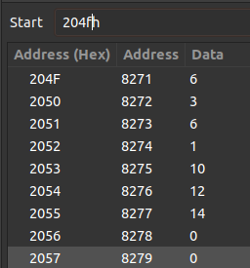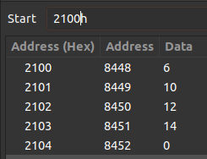

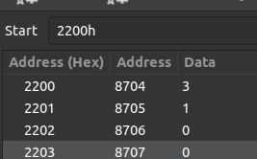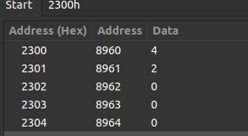

**(Q6)** N numbers are stored in consecutive m/m locations starting from 2050H. The value of N is stored in 204FH. Write a Program to test whether a number stored in 204EH is present in the list, if Present Store its position in the list in 204DH; otherwise store FFH.

|  |
| --- |
| 2200 21 50 20 LXI H, 2050H; Store 2050H in HL Register pair 2203 3A 4F 20 LDA 204FH; Load content of 204FH (Number of elements N) in accumulator  2206 47 MOV B, A; Move N into B register   2207 3A 4E 20 LDA 204EH; Load the Element that needs to be checked(if it is present in the list or not) into the accumulator. 220A BE LOOP: CMP M; Compare the content pointed by Hl pair with accumulator.   220B CA 19 22 JZ MATCHED; If zero flag is set it's a Match. 220E 23 INX H; increment H 220F 05 DCR B; Decreasing N ( the number of Element) 2210 C2 0A 022 JNZ LOOP; if Zero flag is set close loop   2213 3E FF MVI A, 0FFH; Loop ended No match, Load FF into Accumulator. 2215 32 4D 20 STA 204DH; Store it into 204DH 2218 76 HLT     2219 22 4D 20 MATCHED: SHLD 204DH; If match Found, Store HL Pair into 204DH and 204EH. 221C 76 HLT |

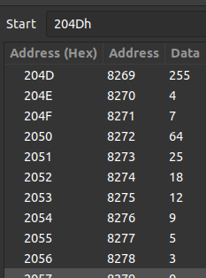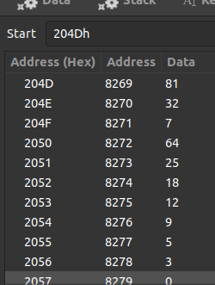

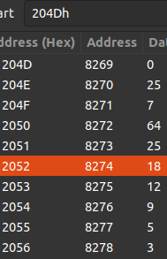

**81 in HEX = 51**

**32 in Hex = 20 i.e (2051H = address of 25 in the consecutive 204DH & 204EH)**